**Project Title: E-Shopper - Your Online Shopping Solution (TBD)**

**Project Description:**

E-Shopper is an online shop that offers a comprehensive and user-friendly platform for both customers and administrators. It aims to solve the hassle of traditional shopping by providing a seamless and convenient experience for users, while also offering robust management tools for administrators to efficiently manage the platform.

**User Side:**

The user side of E-Shopper focuses on delivering a delightful shopping experience for customers. Users can browse through a wide range of products from various categories, add items to their cart, and securely make purchases online. The platform will feature an intuitive and visually appealing user interface, allowing users to easily navigate and find products of interest.

**Key Features for Users:**

1. User Registration and Authentication: Customers can create accounts or log in using their social media profiles, ensuring secure access to their accounts.

2. Product Catalog: A vast selection of products from different categories, with detailed descriptions, images, and pricing information.

3. Cart Management: Users can add products to their cart, edit quantities, and proceed to check out for a seamless shopping experience.

4. Multiple Payment Options: Integration with various payment gateways to offer users a choice of secure payment methods. (Try to use stripe API)

5. Order Tracking: Customers can track their orders in real-time, knowing the status of their purchases until delivery. (Receiving email if there is an update API Mailgun)

**Administrator Side:**

The administrator side of E-Shopper provides powerful tools to manage and monitor the platform efficiently. Administrators will have access to an easy-to-use dashboard with features for inventory management, order processing, customer support, and analytics.

**Key Features for Administrators:**

1. Inventory Management: Administrators can add, edit, and remove products from the catalog, ensuring accurate and up-to-date listings.

2. Order Processing: A dedicated order management system to process and track orders, ensuring timely delivery and customer satisfaction.

3. User Management: Administrators can manage user accounts, track customer activity, and address any account-related issues.

**User Stories**:

1. As a new user, I want to create an account on the E-Shopper platform so that I can start shopping.

2. As a registered user, I want to be able to log in with my credentials so that I can access my account and previous order history.

3. As a user, I want to view detailed product information, including product descriptions, prices, and available stock, to make informed purchasing decisions.

4. As a customer, I want to add products to my shopping cart and have the option to modify the quantities or remove items before proceeding to checkout.

5. As a shopper, I want to have a secure and seamless checkout process with multiple payment options, ensuring my financial information is protected

6. As a user, I want to receive order confirmation and updates on the status of my purchases, including tracking information for shipped items.

7. As a customer, I want to leave reviews and ratings for products I have purchased to help other shoppers make informed decisions.

8. As an administrator, I want to manage the product catalog, including adding new products, updating existing ones, and maintaining accurate stock levels.

9. As an administrator, I want to view and process-incoming orders, update order statuses, and ensure timely and accurate order fulfillment.

10. As a user, I want to receive personalized recommendations based on my browsing and shopping history to discover new products relevant to my interests.

**What we will build:**

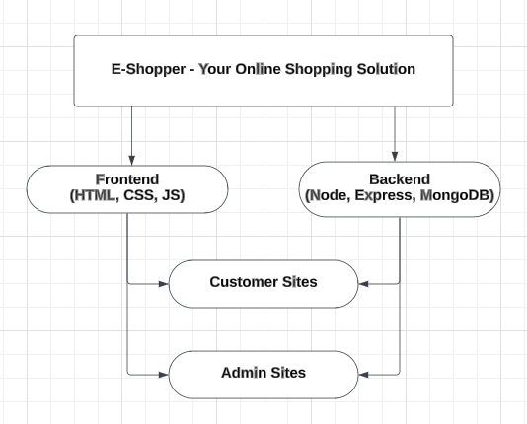

**Key Pages (view):**

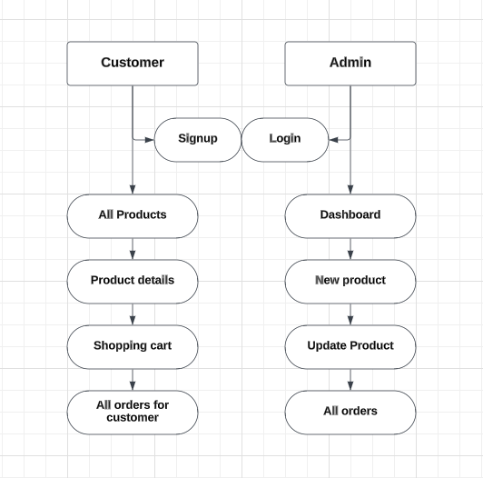

**Data Entities (Models):**

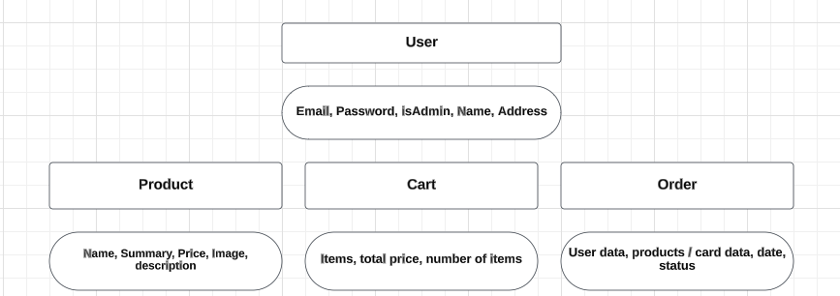

**Extra Website:**

<https://tailwindcss.com/>

<https://github.com/FrancisBourgouin/iceberg/blob/main/planning/DATA_STRUCTURE.md>

<https://github.com/TanStack/router>

<https://reactrouter.com/en/main>

<https://tanstack.com/query/v3/docs/react/overview>

**Stretch:**

1. As a shopper, I want the platform to offer special promotions, discounts, and loyalty rewards to enhance my shopping experience.

2. As a customer, I expect prompt and helpful customer support, with the ability to contact the support team for any inquiries or issues related to my purchases.

3. As an administrator, I want to monitor website analytics, such as sales performance and customer behavior, to make data-driven decisions for platform improvement.

4. As a registered user, I want the option to save multiple delivery addresses for flexibility in receiving my orders.

5. Customer Support: A centralized support system to handle customer inquiries, resolve issues, and provide exceptional customer service.